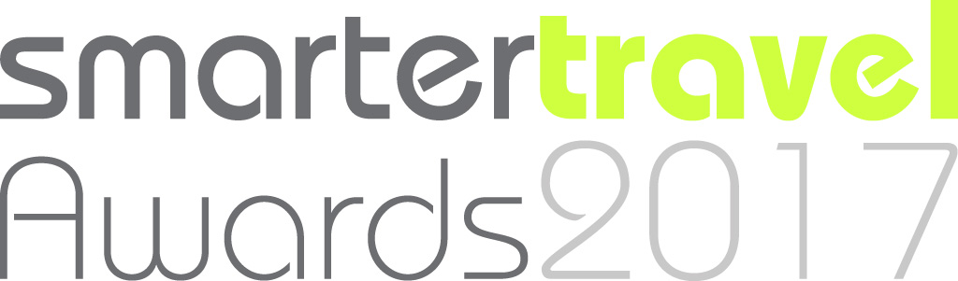

Smarter Travel Awards 2017: The Guide

Guidance for Applicants
Thank you for choosing to apply for the Smarter Travel Awards 2017. We have tried to keep the process as simple as possible, so that busy practitioners working hard on the ground will have time to apply.

1. Choose the category you wish to enter
It is our second year, and we are aiming to keep things straightforward. Some of your work will straddle more than one award, but nonetheless please choose one category for each application. An organisation or business is welcome to submit more than one application.
Choose the category you want to apply for from the list below:
- Best Shared Mobility Service Provider
- Best Smarter Travel Marketing Campaign
- Best Intelligent Mobility Development
- Best Workplace Travel Plan
- Smarter Travel Professional of the Year
- Innovation Award

2. Note the detailed criteria for your Award

Best Shared Mobility Service Provider
This Award recognises the contribution made by shared mobility providers to sustainable transport, such as car clubs, ridesharing matching services, public hire bike services and technological systems that make multi-modal travel practical for the general public.

Specific criteria for this award:
Your application should include details of:
- The benefits experienced by users of shared mobility services - financial, social, environmental, cultural and so on;
- The nature of the relationship(s) between your shared mobility service and other sustainable transport providers or operations - formal, informal; contractual, collaborative; negative, positive; and so on;
- The cost-effectiveness of your transport solution, to the user and to other stakeholders, such as a local authority, an employer, the NHS and so on; and
- Your vision of the future for shared mobility and the role your service will play in it.

Best Smarter Travel Marketing Campaign
This Award recognises smarter travel marketing campaigns that engage with their target audiences, have a measurable impact, are replicable elsewhere and are great value-for-money. They can be single medium or omni-channel. The key question will be: does it
work well?

Specific criteria for this award:
Your application should include details of:
- The target group(s) for your marketing campaign and how you tailored the campaign to meet their needs;
- The level of engagement and results you achieved, such as how many people you reached, follow-up contact, social media traffic and levels of behaviour change achieved; and
- Campaign spend and resourcing, including cost per head, benefits to the user and to other stakeholders, such as a local authority, an employer, the NHS and so on.

Best Workplace Travel Plan
This Award recognises the people who have enabled the journey to an employment location to be improved through the effective adoption of smarter travel principles, with significant numbers of people switching from car driver alone commuting to more sustainable travel.

Specific criteria for this award:
Your application should include details of:
- How and why the intervention to support smarter travel was undertaken by the organization at this time, e.g. parking pressure, change of business location, active and supportive CEO;
- What changes were made, e.g. to the physical environment, transport-related offers, marketing, changes in work practices and support from senior management;
- Data showing the change in travel to work mode on the site, before, during (if available) and after the intervention; and
- How the gains are going to be sustained over time and preferably improved upon.

Smarter Travel Professional of the Year

This Award is for the individual smarter travel professional who has made an outstanding personal contribution to sustainable transport during 2015.

Specific criteria for this award:
Your application should include details of:
- Name and role of nominee;
- Career history;
- Training undertaken (e.g. NVQs, post-graduate courses, MBAs, specialist parking, highways and business management courses);
- Professional and personal achievements;
- Examples of the nominee doing the extra things that makes for outstanding performance;
- Evidence of a consistent application of good practice;
- Ability to overcome constraints (e.g. timescales, funding, objectors) on successful project delivery;
- Commitment to community engagement throughout the course of the project; and
- Testimonials illustrating a high level of respect amongst colleagues.

Innovation Award
This Award is open to all transport related projects and/or products that demonstrate a commitment to technological or design innovation.

Specific criteria for this award:
Your application should include details of:
- Description of the transport that the innovation addresses;
- The extent to which the innovation objectives have been or are being met;
- The extent to which the system, technology or approach is new and unique;
- The technical merit of the innovation;
- Deliverability of the innovation, including practicalities and affordability of the idea;
- The individual or team responsible for delivering the solution; and
- How the innovation has been funded.
The judges will be seeking evidence of how:
- The project has been co-ordinated with the researchers, designers, etc who have developed the innovation;
- The project has received positive measurable results and community feedback;
- The innovation can be applied to other schemes; and
- The innovations demonstrate an advantage in regards to safety, usability or other project goals, compared with conventional approaches.

3. Prepare your application using the online form

Please fill in your application form here: Smarter Travel Awards
Please avoid repetition and make sure you stick to the word limits. The Application Document is straightforward:
Smarter Travel Awards Category
Title (of your project, service or scheme)
Description (no more than 1,000 words)
Evidence (list of supporting material, to be submitted by email – see below)
Contact details (name, position, organisation, landline, mobile, email)

4. Get the formal endorsement of your organisation
or company
We ask your organisation or company to formally endorse the application, with a letter of support signed by a senior person, such as the chief executive, managing director or local authority cabinet member.

5. Submit your application by email by:
Friday 4 August 2017
Your application, plus your supporting evidence – also in digital format – should be emailed by Friday 4 August 2017.
When you email us, please put your title in the subject:
Award you are entering + name of your organisation e.g. BestSmarterTravelApp Borsetshire
Relevant supporting material will include:
- Monitoring and evaluation data and analysis that demonstrates the outcomes and impact to which you refer in your application; and
- Photographs, videos, leaflets and campaign material which will help the panel understand the application.
Remember: send your entry by Friday 4 August 2017.

6. Celebrate at Smarter Travel LIVE! in Milton Keynes on
19 October 2017
Don’t forget to book your place! The winners will be announced on 19 October 2017 during the first day of Smarter Travel LIVE! 2017.

Any questions?
If you have any queries about the Awards process or the categories, please email: smartertravel@landor.co.uk
Alternatively, please call 0161 368 6603, to talk with the Smarter Travel Awards team.

